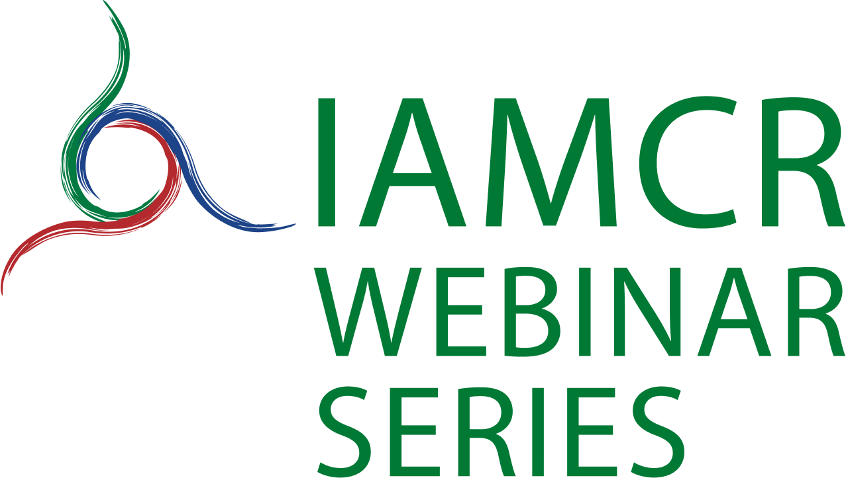

IAMCR Webinar Series – Application form

Webinars are held from September to June. Applications are now being received for the second semester of 2021.
Applications must be formally presented by a Section/Working Group, Task Force or Committee. The complete application form should be emailed to the Webinar Series coordinator Andrea Medrado (a.medrado@westminster.ac.uk) with subject: IAMCR Webinar proposal: {title of your webinar}
Applications should be received at least 8 weeks before your planned webinar. The Webinar Committee will evaluate applications and an effort will be made to respond to all complete applications within 4 weeks.

Applicant details

Sponsoring section, working group, committee or task force

Provide details of the main applicant and any partners. Include the contact details of the main contact person or persons and indicate those who are IAMCR members either individually or through their institutions.

Webinar details
1) Webinar title
2) Description
Provide a maximum 300 word description of the webinar. You may also attach documents such as a call for proposals or provide URLs. Include, for example, information about the agenda, speakers, participants, and outcomes.
3) Objectives
4) Audience
What is the target audience for the webinar? Webinars are generally open to all IAMCR members. A limited number of non-members may be invited.
5) Proposed format (for example roundtable discussion, paper presentations, interview…)
6) Speakers
Provide the name, affiliation and short bio (maximum 25 words) of each presenter/speaker. Indicate whether they are members of IAMCR.
7) Moderator/Chair
Provide the name of the person that will be moderating/chairing the webinar.
8) Proposed date and time (starting September 2021)
9) Proposed duration (60 min to 120 min)
10) Agenda
Please provide a short script detailing each segment of the webinar, who will be in charge and its duration. For example:
Introduction by moderator John Doe – 5 minutes
Speaker 1 – 10 minutes
Q&A for speaker 1 – 5 minutes
11) Intellectual property
Webinar presenters are responsible for obtaining copyright clearance on any materials presented. Please advise if there are any copyright issues in your planned webinar and if they have been cleared.

Web information
If your webinar is approved, the information you provide below will be included on the IAMCR website and in the announcement of the webinar
Full title of your event:

Short title (if any):
Description:
(maximum 250 words including presentation of speakers)

Proposed date and time (applications must be submitted at least 8 weeks before the planned event):

Convenor(s) / Organiser (s):
Brief description of institution(s) or individual(s)

Contact email:

Please send head and shoulder photos of speakers, logos of any co-sponsoring organisations, etc.

After the event has taken place, a short article (250 to 500 words) must be submitted to membership@iamcr.org, to be published on the IAMCR website.

Thank you!

